International Conference on X-ray optics and Applications 2024  
(bold face, pt 14, Times New Roman)

Asd. Author11, Bnm. Author21, and Cvb. Author32

Asd. Author1

1 *Department of X-ray optics, Graduate School of Engineering, Optic University,*

*1-1-1 Minato Mirai, Nishi-ku, Yokohama 220-0012, Japan*

2 *Research Center for X-ray detectors and sources, Optic University,*

*1-1-1 Minato Mirai, Nishi-ku, Yokohama 220-0012, Japan*

Email: xopt-conference@opicon.jp

**1. General information**

An A4 format abstract is required for each presentation. Maximum length is two pages. Standard length is one page. If the abstract is divided into a few sections, the sections should be numbered like “1. Introduction”. Acknowledgements and References should not be numbered. In the case of one section, numbering is not necessary.

Contributed papers must be in English and should report an original work. Invited speakers should also prepare abstracts in the same format summarizing their presentations. The authors are responsible for the content and style of the abstract. No editing or retyping will be carried out by the organizing committee. Contributed papers which do not conform to the format described below may be rejected. Contribution submitted by any other paths cannot be accepted. **Please submit your paper in pdf format (pdf file is preferable), using submission site of XOPT2024. The deadline for receipt of abstracts is January 4, 2024.** All contributed papers will be refereed by the organizing committee, and authors will be notified of acceptance or rejection of their abstracts. Accepted contributions and invited papers will appear on the book of Extended Abstract that will be distributed to the participants at the symposium site.

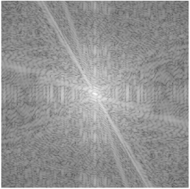

Fig. 1. An example of figures.

**2. Detailed information**

*2.1 Format*

The abstract should be typewritten on A4 format papers with one column. The maximum length, including figures and references, is two pages for both invited and contributed papers. The abstract must be headed by the title of paper, author(s), affiliation(s), postal address(es), and corresponding author’s e-mail address, phone and fax numbers. Please use single line spacing. Show a photograph of the speaker. An example is shown in the first page.

Place a blank line between the title and author name(s), between the author name(s) and affiliation(s), between the e-mail address and main text, and between the sections. The pages must not be numbered. Set the top, bottom, left and right margins to 30 mm. Place an indent of 6 mm at the beginning of each paragraph. The fonts should be Times New Roman (or similar fonts).

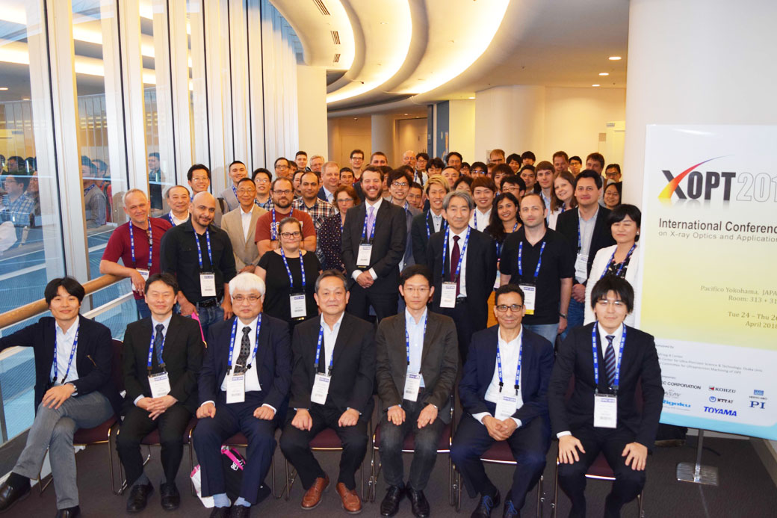

Fig. 2. Photograph of XOPT2018.

*2.2 Figures and Tables*

Monochromatic figures are recommended. Color figures or photographs can be used, but please note that the book of Abstract will be printed in black and white. A caption should be attached to each figure and table. An example is shown in Fig. 2.

*2.3 References*

List and number all references at the end of the paper. When referring to them in the text, type the corresponding reference number between brackets as shown at the end of this sentence [1]. Another examples are also listed [2, 3].

**Acknowledgements**

This research was supported by JSPS KAKENHI (Grant No. JPXXXXXX), the XXXX project of JST, and XXXX Foundation. The use of BL29XUL at SPring-8 was supported by RIKEN. We acknowledge XXXX for their valuable discussions.

**References**

1. U. Osaka and C. R. Ultra, *Jpn. J. Appl. Phys.* **50** (2006) 1.
2. U. Osaka, *Proceedings of the 10th International Conference on Precision Engineering* (2001) 15.
3. S. M. Sze, *Physics of Semiconductor Devices* (2016) 245.